Conjunctions
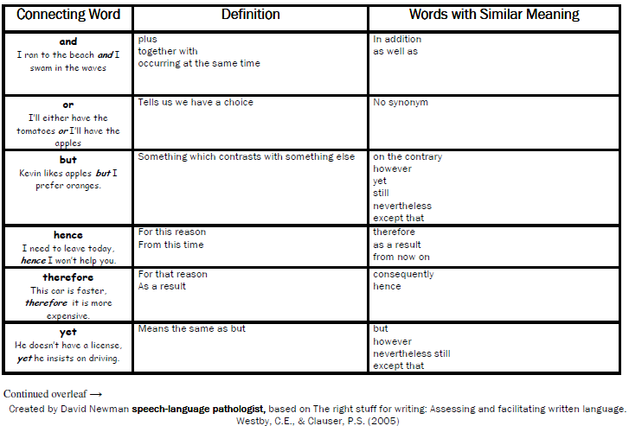

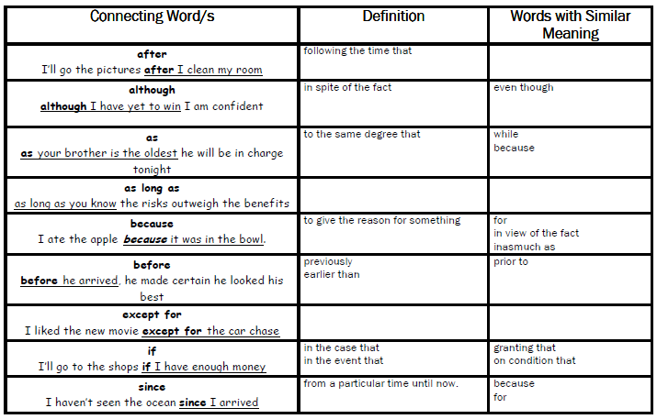

Conjunction | Concept | Example
because | Cause & Effect | I was feeling sick because I had a cold
If | Condition | If it starts raining, I will put my coat on
before | Time / Sequence | You have lunch before you go outside
after | Time / Sequence | You can go outside after you finish your tea
but | Comparison / Contrast | I thought it would be hot but it was cold
or | Options | I could read my book or I could go outside
when | Time | You can go outside when the bell goes
so | Cause & Effect | I was hungry so I got something to eat
until | Time | You will have to stay until everyone is finished
instead of | Exclusion | I went to the library instead of going to the park

